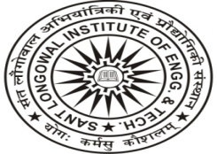 | Sant Longowal Institute of Engineering and Technology  Longowal, Dist. Sangrur, Punjab – 148106  (Deemed University under MHRD)

Ref. No. PUR/09/17/ Date:

NOTICE

The last date for submission of bids for AMC of Office Automation Software installed in Accounts & Store & Purchase Section through NIQ No. PUR/64/08/664 dated 04-08-2017 has been extended upto 04-09-2017.

Faculty In-charge
(Store & Purchase)

